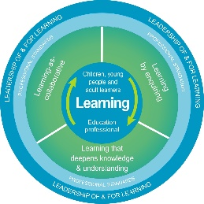
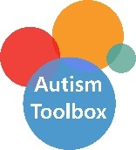
Autism Toolbox - Understanding Autism
Professional Reflection and Planning Tool:
This professional reflection and planning tool support opportunities to reflect on your knowledge and understanding of the areas highlighted within the Autism Toolbox and help you plan the next steps in your professional learning.
Name |  |  | Establishment |  | Date
Toolbox Focus area |  | My reflections on the Toolbox information |  | My next steps and priorities for my professional learning.
Understanding Autism

Communication

Environment
Sensory Processing

Reflective Prompts | Next Steps and Priorities for my Professional Learning.
How does my understanding of autism impact on my practice?
How well does my school community ethos reflect an understanding of autism?

