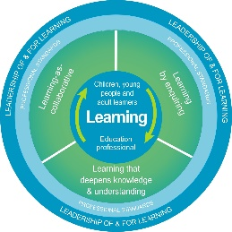
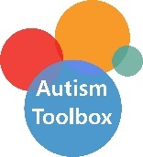
Autism Toolbox - Transitions
Professional Reflection and Planning Tool:
This professional reflection and planning tool support opportunities to reflect on your knowledge and understanding of the areas highlighted within the Autism Toolbox and help you plan the next steps in your professional learning.
Name |  |  | Establishment |  | Date
Toolbox Focus area |  | My reflections on the Toolbox information |  | My next steps and priorities for my professional learning.
Family engagement
Transitions – micro
Transitions – major

Reflective Prompts | Next Steps and Priorities for my Professional Learning.
How well does my planning and support reflect the transitional needs of my autistic learners?
How do we know as a school community know that our ethos, practice and policies support the range of transitions our autistic learners experience?

