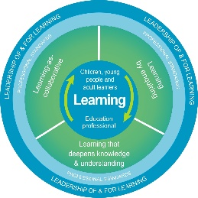
Autism Toolbox - Supporting Learners and Families
Professional Reflection and Planning Tool:
This professional reflection and planning tool support opportunities to reflect on your knowledge and understanding of the areas highlighted within the Autism Toolbox and help you plan the next steps in your professional learning.
Name |  |  | Establishment |  | Date
Toolbox Focus area |  | My reflections on the Toolbox information |  | My next steps and priorities for my professional learning.
Effective Partnerships & Communication
Activities of daily living
Educational support

Reflective Prompts | Next Steps and Priorities for my Professional Learning.
How do I know my practice reflects the information and suggestions on supporting learners and families?
How do we know as a school community that our ethos and policies meet the needs of our autistic learners and their families?

