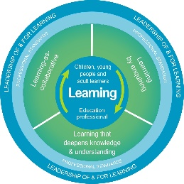
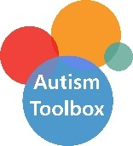
Autism Toolbox - Social and Emotional Wellbeing
Professional Reflection and Planning Tool:
This professional reflection and planning tool provide opportunities to reflect on your knowledge and understanding of the areas highlighted within the Autism Toolbox and help you plan the next steps in your professional learning.
Name |  |  | Establishment |  | Date
Toolbox Focus area |  | My reflections on the Toolbox information |  | My next steps and priorities for my professional learning.
Mental Health and Wellbeing
Play and Leisure
Anxiety, stress, coping strategies and resilience
Relationships

Reflective Prompts | Next Steps and Priorities for my Professional Learning.
How do I know how well I am supporting my autistic learners’ social and emotional wellbeing?
How do we know as a school community that our ethos, practice and policies support our autistic learners social and emotional wellbeing?

