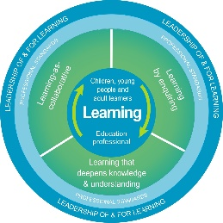
Autism Toolbox - The Scottish Context and Inclusion within the School Community
Professional Reflection and Planning Tool:
This professional reflection and planning tool support opportunities to reflect on your knowledge and understanding of the areas highlighted within the Autism Toolbox and help you plan the next steps in your professional learning.
Name |  |  | Establishment |  | Date
Toolbox Focus area |  | My reflections on the Toolbox information |  | My next steps and priorities for my professional learning.
Scottish Context, Legislative and Policy Framework – Inclusion and Autism

Inclusion and supporting learners

Reflective Prompts | Next Steps and Priorities for my Professional Learning.
How inclusive do I feel my practice is and how do I know?
How inclusive do I feel my school community is and how do we know?

