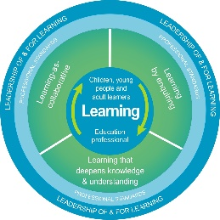
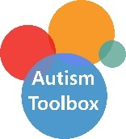
Autism Toolbox - Resources
Professional Reflection and Planning Tool:
This professional reflection and planning tool provide opportunities to reflect on your knowledge and understanding of the areas highlighted within the Autism Toolbox and help you plan the next steps in your professional learning.
Name |  |  | Establishment |  | Date
Toolbox Focus area |  | My reflections on the Toolbox information |  | My next steps and priorities for my professional learning.
Free templates and resources
Technology

Reflective Prompts | Next Steps and Priorities for my Professional Learning.
How effectively do I use the free resources and information to support autistic learners and curriculum accessibility available on the Toolbox?
How do we know that colleagues and partners within our school community are aware of and access the resources to support curriculum accessibility available on the Toolbox?

