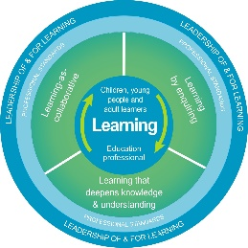
Autism Toolbox - Assessing and Planning
Professional Reflection and Planning Tool:
This professional reflection and planning tool support opportunities to reflect on your knowledge and understanding of the areas highlighted within the Autism Toolbox and help you plan the next steps in your professional learning.
Name |  |  | Establishment |  | Date
Toolbox Focus area |  | My reflections on the Toolbox information |  | My next steps and priorities for my professional learning.
Partnership working
Planning, monitoring, reporting and support for autistic learners
Diagnosis of Autism

Reflective Prompts | Next Steps and Priorities for my Professional Learning.
How do I know my approaches to assessment, monitoring, reporting and support is effective for my autistic learners?
How do we know as a school community that our policies for assessment, monitoring and reporting also meet the needs of our autistic learners?

